# Logistic Model to classify the kddcup99 data

## Process of the data

* The last column is the label, we treat them as two part. One is” normal “and the other is” attack”
* The second, third and fourth column are characters. We use the following code to transfer these character into numbers:

for (i in 1:41){

kddcup_train[,i]=as.numeric(kddcup_train[,i])

kddcup_test[,i]=as.numeric(kddcup_test[,i])

}

* Finally we transfer the data into matrix only with numbers

## Implement of the data

### Cross validation to find the optimal lambda

We implement the data with cross validation (generalized linear model) to find the optimal lambda with the following model:

cv_model=cv.glmnet(a1[1:5000,-42],a1[1:5000,42],family="binomial")

I sample the data with size 5000 and 2000 respectively. 5000 data is the training data and 2000 data is the testing data.

I run the algorithm 5 times and you can see the figures in the next page.

From the figures, we can see that the optimal lambda is 0.000397.

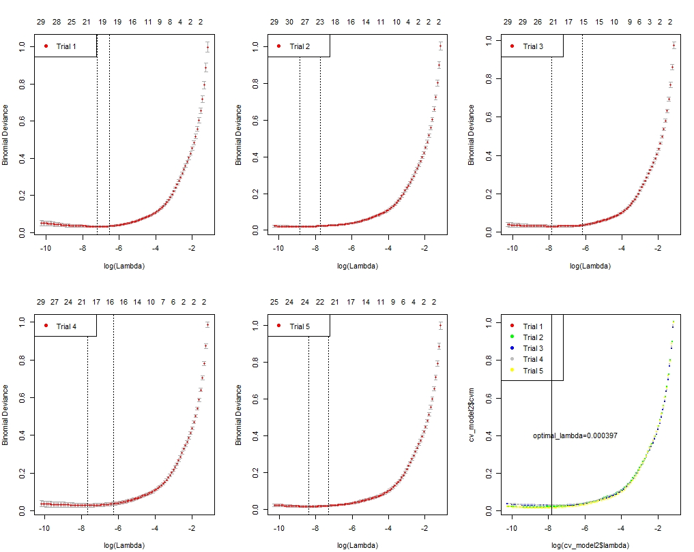

### Train with larger size training data (20000) and larger size test data(5000)

model=glmnet(kddcup_train[1:20000,-42],kddcup_train[1:20000,42],family="binomial")

#do test on test data

start_time=proc.time()

pre.test=predict(model,kddcup_test[1:5000,-42],0.000397,"class")

end_time=proc.time()

run_time=end_time-start_time

errorrate.test=sum((pre.test!=kddcup_test[,42]))/nrow(kddcup_test)

The result we get are in the following:

> errorrate.test

[1] 0.0084

> run_time

user system elapsed

0.02 0.03 2.66

|  |  |
| --- | --- |
| Average time of one data stream(s) | Error rate |
| 1.33e(-4) | 0.0084 |

# Code Appendix :

#logistic model of kddcup99 classification

#this is the package we used

library("glmnet")

#import the data into the R studio

kddcup <- read.csv("C:/Users/Christina/Desktop/kddcup.data_10_percent_corrected", header=FALSE)

# we sample the data to get 5000 training data and 2000 test data

kddcup=as.matrix(kddcup)

data=function(kddcup){

kddcup_1=sample((nrow(kddcup)),size=5000,replace = FALSE, prob = NULL)

kddcup_2=sample((nrow(kddcup)),size=2000,replace = FALSE, prob = NULL)

kddcup_train=kddcup[kddcup_1,]

kddcup_test=kddcup[kddcup_2,]

#process the data in order to apply the logistic model

# process the last column into two parts

for (i in 1:2000){

if (kddcup_test[i,42]=="normal."){

kddcup_test[i,42]=1}

else{

kddcup_test[i,42]=2

}

}

for (i in 1:5000){

if (kddcup_train[i,42]=="normal."){

kddcup_train[i,42]=1}

else{

kddcup_train[i,42]=2

}

}

kddcup_train=as.data.frame(kddcup_train)

kddcup_test=as.data.frame(kddcup_test)

colnames(kddcup_train)=c(paste("x.",1:41,sep=""),"Y")

colnames(kddcup_test)=c(paste("x.",1:41,sep=""),"Y")

#process the data in order to apply the svm method

#process the x and through this way we can transfer the characters into numbers

for (i in 1:41){

kddcup_train[,i]=as.numeric(kddcup_train[,i])

kddcup_test[,i]=as.numeric(kddcup_test[,i])

}

kddcup_train[,42]=as.factor(kddcup_train[,42])

kddcup_train[,2]=as.factor(kddcup_train[,2])

kddcup_train[,3]=as.factor(kddcup_train[,3])

kddcup_train[,4]=as.factor(kddcup_train[,4])

kddcup_train[,7]=as.factor(kddcup_train[,7])

kddcup_train[,12]=as.factor(kddcup_train[,12])

kddcup_train[,21]=as.factor(kddcup_train[,21])

kddcup_train[,22]=as.factor(kddcup_train[,22])

kddcup_test[,42]=as.factor(kddcup_test[,42])

kddcup_test[,2]=as.factor(kddcup_test[,2])

kddcup_test[,3]=as.factor(kddcup_test[,3])

kddcup_test[,4]=as.factor(kddcup_test[,4])

kddcup_test[,7]=as.factor(kddcup_test[,7])

kddcup_test[,12]=as.factor(kddcup_test[,12])

kddcup_test[,21]=as.factor(kddcup_test[,21])

kddcup_test[,22]=as.factor(kddcup_test[,22])

kddcup_train=data.matrix(kddcup_train)

kddcup_test=data.matrix(kddcup_test)

kddcup_train_test=rbind(kddcup_train,kddcup_test)

return (kddcup_train_test)

}

# first we use the generalized linear model and cross validation to deternime the optimal lambda

#we run the algorithm 5 times

a1=data(kddcup)

a2=data(kddcup)

a3=data(kddcup)

a4=data(kddcup)

a5=data(kddcup)

cv_model1=cv.glmnet(a1[1:5000,-42],a1[1:5000,42],family="binomial")

cv_model2=cv.glmnet(a2[1:5000,-42],a2[1:5000,42],family="binomial")

cv_model3=cv.glmnet(a3[1:5000,-42],a3[1:5000,42],family="binomial")

cv_model4=cv.glmnet(a4[1:5000,-42],a4[1:5000,42],family="binomial")

cv_model5=cv.glmnet(a5[1:5000,-42],a5[1:5000,42],family="binomial")

#plot the figures to find optimal lambda

par(mfrow=c(2,3))

plot(cv_model1,pch=19,col="red")

legend("topleft",legend="Trial 1",col="red",pch=19)

plot(cv_model2,pch=19,col="green")

legend("topleft",legend="Trial 2",col="red",pch=19)

plot(cv_model3,pch=19,col="blue")

legend("topleft",legend="Trial 3",col="red",pch=19)

plot(cv_model4,pch=19,col="grey")

legend("topleft",legend="Trial 4",col="red",pch=19)

plot(cv_model5,pch=19,col="yellow")

legend("topleft",legend="Trial 5",col="red",pch=19)

plot(log(cv_model2$lambda),cv_model2$cvm,pch=19,col="red",cex=0.1)

points(log(cv_model2$lambda),cv_model2$cvm,pch=19,col="green",cex=0.1)

points(log(cv_model3$lambda),cv_model3$cvm,pch=19,col="blue",cex=0.1)

points(log(cv_model4$lambda),cv_model4$cvm,pch=19,col="grey",cex=0.1)

points(log(cv_model5$lambda),cv_model5$cvm,pch=19,col="yellow",cex=0.1)

legend("topleft",legend=c('Trial 1','Trial 2','Trial 3','Trial 4','Trial 5'),col=c('red','green','blue','grey','yellow'),pch=19)

abline(v=log((cv_model1$lambda.min+cv_model2$lambda.min+cv_model3$lambda.min+cv_model4$lambda.min+cv_model5$lambda.min)/5))

text(x=-6.5,y=0.4,label="optimal_lambda=0.000397")

# we train the model with a larger training data,say 20000 training data and 5000 testing data

kddcup_1=sample((nrow(kddcup)),size=20000,replace = FALSE, prob = NULL)

kddcup_2=sample((nrow(kddcup)),size=5000,replace = FALSE, prob = NULL)

kddcup_train=kddcup[kddcup_1,]

kddcup_test=kddcup[kddcup_2,]

#process the data in order to apply the logistic model

# process the last column into two parts

for (i in 1:5000){

if (kddcup_test[i,42]=="normal."){

kddcup_test[i,42]=1}

else{

kddcup_test[i,42]=2

}

}

for (i in 1:20000){

if (kddcup_train[i,42]=="normal."){

kddcup_train[i,42]=1}

else{

kddcup_train[i,42]=2

}

}

kddcup_train=as.data.frame(kddcup_train)

kddcup_test=as.data.frame(kddcup_test)

colnames(kddcup_train)=c(paste("x.",1:41,sep=""),"Y")

colnames(kddcup_test)=c(paste("x.",1:41,sep=""),"Y")

#process the data in order to apply the svm method

#process the x and through this way we can transfer the characters into numbers

for (i in 1:41){

kddcup_train[,i]=as.numeric(kddcup_train[,i])

kddcup_test[,i]=as.numeric(kddcup_test[,i])

}

kddcup_train[,42]=as.factor(kddcup_train[,42])

kddcup_train[,2]=as.factor(kddcup_train[,2])

kddcup_train[,3]=as.factor(kddcup_train[,3])

kddcup_train[,4]=as.factor(kddcup_train[,4])

kddcup_train[,7]=as.factor(kddcup_train[,7])

kddcup_train[,12]=as.factor(kddcup_train[,12])

kddcup_train[,21]=as.factor(kddcup_train[,21])

kddcup_train[,22]=as.factor(kddcup_train[,22])

kddcup_test[,42]=as.factor(kddcup_test[,42])

kddcup_test[,2]=as.factor(kddcup_test[,2])

kddcup_test[,3]=as.factor(kddcup_test[,3])

kddcup_test[,4]=as.factor(kddcup_test[,4])

kddcup_test[,7]=as.factor(kddcup_test[,7])

kddcup_test[,12]=as.factor(kddcup_test[,12])

kddcup_test[,21]=as.factor(kddcup_test[,21])

kddcup_test[,22]=as.factor(kddcup_test[,22])

kddcup_train=data.matrix(kddcup_train)

kddcup_test=data.matrix(kddcup_test)

kddcup_train_test=rbind(kddcup_train,kddcup_test)

#get the model

model=glmnet(kddcup_train[1:20000,-42],kddcup_train[1:20000,42],family="binomial")

#do test on test data

start_time=proc.time()

pre.test=predict(model,kddcup_test[1:5000,-42],0.000397,"class")

end_time=proc.time()

run_time=end_time-start_time

errorrate.test=sum((pre.test!=kddcup_test[,42]))/nrow(kddcup_test)

#

kddcup_train_x=data.matrix(subset(kddcup_train,select=-Y))

kddcup_train_y=subset(kddcup_train,select=Y)

kddcup_test_x=subset(kddcup_test,select=-Y)

kddcup_test_y=subset(kddcup_test,select=Y)

model=glmnet(kddcup_train_x,kddcup_train_y,"binomial")

> errorrate.test

[1] 0.0084

> run_time

user system elapsed

0.02 0.03 2.66